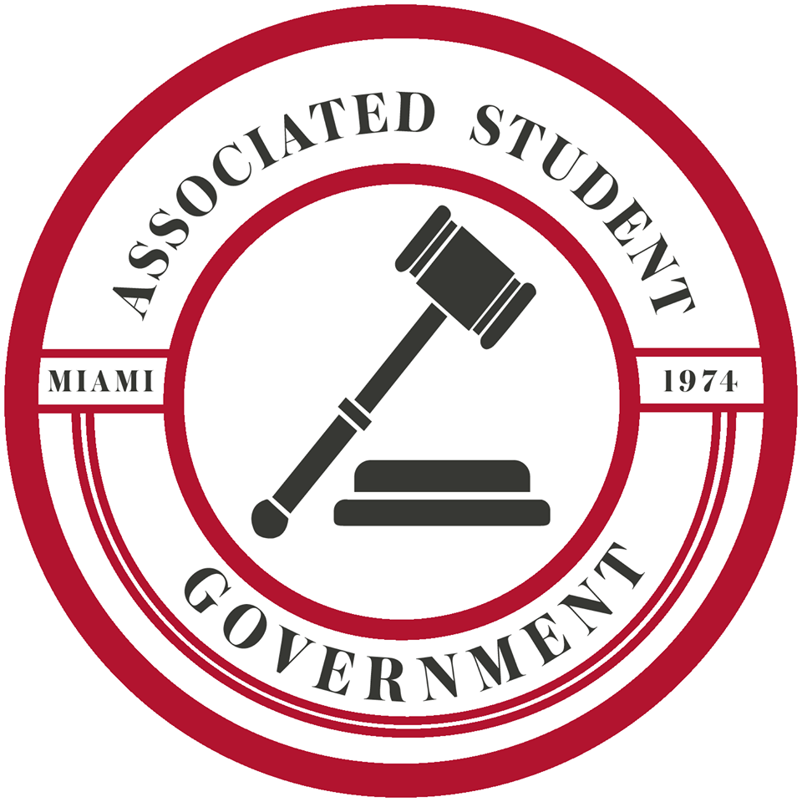
STUDENT SENATE AGENDA
November 6, 2018
Joslin Senate Chamber

- Call to Order
  - This Meeting will be livestreamed on Facebook

- Two Minutes of Silence

- Roll Call
  - Senator Meissner alternate present
  - Senator Radilla present

- Announcements from the Chair
  - DAC Global Holiday Party on Thursday at 6pm. It is black tie.
  - The On Campus Affairs Committee wants you to fill out a poll that was sent to your email
  - Happy voting day
  - Student guests can speak in debate. We are going to carry out respectful debate. At the end of the day we are done and all friends

- Consent Calendar
  - Approval of Student Senate Minutes from October 30
  - Approval of Executive Cabinet Minutes from November 4
  - Approval of Elections Committee Minutes from October 29
  - Approval of On-Campus Affairs Committee Minutes from October 29
  - Approval of Safety Committee Minutes from November 2
  - Approval of Off-Campus Affairs Committee Minutes from October 21
  - Approval of Off-Campus Affairs Committee Minutes from November 4
  - Approval of Oversight Committee Minutes from October 22
  - Approval of Steering Committee Minutes from November 2
  - Approved Unanimously

- Student Concerns
  - Sen. Galarza: One stall in the women’s restroom in Armstrong
    - Committed to the On-Campus Affairs Committee. Please report back in two weeks.
  - Sen. Johns: Grass padded down on east side of Laws Hill from students walking. The school should possibly consider constructing a sidewalk
    - Committed to the Infrastructure and Sustainability Committee. Please report back in two weeks.
  - Sen. Silbey: Double majors are having a hard time trying to register
    - Committed to the Academic Affairs Coalition. Please report back in two weeks.
  - Sen. Niekamp: Order of registration and which students get priority. Students are not aware of how the process works
  - Sen. Xu: Men’s restrooms, people not flushing the toilet
  - Sen. Davis: People with priority registration are not getting priority
  - Sen. Gale: Registration override not public
    - Committed to the Academic Affairs Coalition. Please report back in two weeks.

- Reports
  - Julia Koenig, College of Education, Health and Society Academic Senator
    - Sexual assault prevention:
      - Miami has purchased a app called Rave Guardian
      - Features include: Message MUPD and Timer
        - It is not anonymous, but it does have an anonymous report option
      - ASG Lighting Audit
        - ASG, RHA, SDAC, and HAWKS
        - Conclusion: Pretty good overall lighting in the quad
        - Blue lights: serves as an emergency call button, Wi-Fi hotspots and emergency speaker system
          - We all agree there should be more of these blue lights
          - Ingress policy: There was some dissatisfaction with the lighting by the doors that are open. No police bike patrol
        - SIV Prevention workshop: Follow up meeting this Wednesday at 7:30pm
    - Question:
      - Sen. Gale: Can you be anonymous on the app?
        - Not through the app but on the resource page you can report anonymously.
      - Sen. McGuff: What exactly happens when you press a blue light?
        - It immediately connects you with MUPD
      - Sen. Kufrin: How do you spread the word about this on campus?
        - Miami purchased this app. ASG will spread the word
      - Sen. Turk: There are a lot of lights that were burnt out, did we relay this message?
        - Yes
      - Sec. Rose: Are you concerned about the language used in emails after a report?
        - Some language is mandated by the state, but I will look into this

- Old Business

- New Business
  - SR 181906 “A Resolution to Expand the Sale of Emergency Contraceptive Pills to All Market Locations”
    - This is expanding accessibility on campus for pregnant tests. This legislation supports the expansion of emergency contraceptive pills to all campus market locations with Mulaa. We should support the health and wellness of all of our students. This is an availability issue
    - Questions:
      - Sen. Siegel: Are these pills already available at the health center?
        - Yes. They are charged to your bursar
      - Sen. Turk: Do you have data from Miami University?
        - No but we tracked it with other colleges. We knew it would cause a lot of controversy if we looked for data around Miami
      - Par. Mellott: How much are contraceptives? Do student fee dollars go to this?
        - It would cost the same as the health center. At off campus locations it is $46-$50.
        - No
      - Sen Gale: Could this encourage unsafe sex? Do you think parents will be shocked to know the same money that is used for printing can be used for emergency contraceptives?
        - I do not think it will encourage unsafe sex. I cannot speak to student activities. Having it available for students who do choose to have sexual relations is important
        - No, I do not know if it will shock parents. A lot of universities have the ability to use Mulaa off campus, but we do not have this option
      - Sen. Radilla: Are emergency contraceptives subsidized by health insurance?
        - No, it was purchased in bulk by Miami that is why it is subsidized
      - Sen. Davis: Do you have the statistics of the sales at the health center?
        - No
      - Sen. Kyle: Can you tell what is bought at markets?
        - No, it just says where and how much
      - Sen. Carmean: Are we buying the contraceptives from trihealth?
        - No. We are buying it in bulk from the contractors
      - Sen. Silbey: Will Miami profit from these sales?
        - Miami profits from whatever they sell. I do not think this is what we focus on, we should focus on the health of our students
    - Debate:
      - Sen. McGuff: In regard to what parents may think I want to say we sell condoms in the vending machines
      - Sen. Davis: This seems pretty ethical and a clear decision
      - Par. Mellott: For the most part resident life and dining covers itself. Any money Miami makes with this will go back to resident life and dining
      - Sen. Liber: I wanted to echo Par. Mellott
      - Sen. Siegel: We should be advocating for our students. I am in full support for this bill and our students. It is an accessibility need
      - Sen. Gale: I 100% agree with this bill. I think we should look to see if it is financially feasible
      - Sen. Turk: I want to echo everyone. I am concerned that we did not survey Miami students just to make sure we are appealing to our student body
      - Sen. Daly: Yield to guest. I think this is an accessibility issue and important to have on campus
        - President of Students for Life: Opposed to this legislation because Plan B is already available on campus. This legislation will create unnecessary conflict. You should take into account our concerns if you want to be representative of the whole student body
      - Sen. Carmean: I do not know how realistic this is to have in our markets. Will we be IDing people? You must be a certain age to purchase a pregnancy test
      - Sen. Kamara: I hear both sides of this argument. We took other perspectives into consideration. Accessibility, affordability, and hours are much better at the markets. We should not focus on unprotected sex. We should take our personal beliefs aside and focus on the students
      - Sen. Silbey: Plan B is not moral, and Miami should not make a profit from death
      - Sen. Radilla: I applaud Jannie and Brandon. We acknowledge the concerns of the people who dissent, but this is an accessibility issue
      - Sen. Mitsch: The university will make a profit from this that goes to President Crawford’s paycheck
      - Sen. Small: It is “available” but not available to all students and it should be. Let’s pass this bill and see if it would happen
      - Sen. Davis: This is an incredibly important resource for victims of sexual assault
      - Sen. Bertog: We do not know the effects of putting these in a market. Can cause a problem
      - Sen. Stidham: The idea that taking plan B pill would expand unsafe sex would mean that taking Plan B is pleasurable and it is not
      - Sen. Gale: Yield to guests. I agree with this bill, but I think there are issues with this bill that we do not know how to fix
        - Guest from Students for Life: I believe this is an abortion. If Plan B is brought to the market would there be an educational label?
        - Sen. Kamara: It is on the Plan B box
        - Guest from Students for Life: Thank you for showing us respect. A lot of students do not know they can get plan B already on campus. Maybe instead we can expand awareness of this?
        - Sen. Kamara: Moving this on campus increases the number of contraceptive pills we can have on campus
    - SR 181906 is approved

- Special Business of the Day
  - Dr. Stephen Large, Assistant Vice President of Health and Wellness
    - You look familiar because I have met with you already. Dr. Curme is returning to faculty and now my role is to care for the health and wellness of our student. I am focusing on sexual violence and drugs/alcohol on campus. My initial observations at Miami would be that Miami is a great place with great students. You all are very bright and committed to the institution. I am struck by the resources that exist on this campus. We have a lot going on on-campus that pertains to health and wellness. I want to be wise with how we are using our resources. Some concerns are that our students drink a lot. I knew it was going to be intense. I think the vast majority of our students are making good decisions but there is a group who are making high risk choices and because of our campus structure, it makes it seem like all our students are making these choices but that is not the case. I want to hear from you now.
    - Questions:
      - Sen. Gale: What is your general impression of drug culture at Miami?
        - Most of my impressions are based off my conversations from students on ASG. Alcohol is a drug too and most common on campus. Marijuana and stimulants (like Adderall and cocaine) are more prevalent on campus
      - Sen. McGuff: Miami has a drinking culture problem and I was wondering how you think drinking impacts the health on campus?
        - In college I made poor decisions about drugs and alcohol in college. There is a difference between mistakes and using drugs as a coping mechanism. It absolutely impacts mental health. It is so easy to attack Miami students when it comes to alcohol because it is visible. I am so impressed with our students here and it pains me when our institution is only known for alcohol
      - Sen. Kufrin: What are realistic ways to combat drinking culture on campus?
        - We are doing all of them and that is the problem. We are doing prevention education and response very well. There are more cultural variables that have not been touched and it involves a more long-term plan to fix. You may not see immediate changes, but work is being done. We are doing legislative work in Columbus to change the Home Rule. Your state rule trumps any jurisdiction rule. That takes time and effort. That is only one Jenga piece of the whole Jenga tower. Landlords hold a lot of power over Miami students. I think they sometimes exploit our students. There is not a massive problem at Miami only a visible problem. Every Monday I look at the reports from OPD. There are a lot of reports about students passed out alone and it makes me wonder where are there friends? We are all Miami and we should look out for each other.
      - Sen. Radilla: Can you elaborate on wait times at mental health services?
        - When you go into counseling you receive an initial consultation. Then you are paired with a therapist which takes a day or two. That is very responsive, here is where it gets tricky. You now have a variety of options. A bulk of students prefer individual face to face treatment. That option takes longer. There are choices not a waitlist
      - Sen. Silbey: You spoke about resources on campus for students, what resources are being underutilized?
        - I misspoke, students need more resources. We spend a lot of time and resources identifying the problem. I think we know the problem and I want to move forward on it
      - Sen. Siegel: You mentioned at the retreat that you are not concerned about underage drinking but about how students use alcohol but has that clashed with other administrators?
        - It is illegal to drink unless you are 21. If you choose to break that law I want you to be safe and smart. I still believe that, but I do feel the need to be careful about how I phrase things because the law is the law. We need to focus on student’s safety and wellness
      - Sen. Gale: How do you feel about the alcohol policy differencing alcohol severity?
        - 105A and 105B are different. 105A is possession of liquor rather than beer. This policy came at the recommendation from ACC. I do not like this policy because I do not like how punitive we are in general. We suspend too many students at Miami. I do not know that punishment is the best way to shape behavior
      - Sec. Rose: I know you discussed satellite stations of mental health services and Diversity Affairs?
        - Right now, to get counseling you have to go to counseling services. We are looking into counseling at other places on campus. A student can simply drop in with little paperwork and without a meeting. I have discussed this with people now it is just about the logistics
      - Sen. Silbey: High risk behavior is visible at Miami; how do we increase positive visibility?
        - It is about sharing of the story. The behavior is happening, but it is so easy to focus on the negatives rather than the positive. It is about telling the story better

- General Announcements
  - Speaker Pro Tempore Andres: This week’s office cleaners: Senator Silbey and Senator Koenig
  - Sen. Kamara: Thanks for passing the bill please speak to Brandon and I if you have any questions
  - Sen. Sarkasian: Sign up for tabling
  - Sec. Zele: Sign up for constituent tabling. Senator of the Month- Senator Frye
  - Sec. Meleka: Congratulations to this body it is not easy to bring in people who disagree with you to be more representative of the student body
  - Sen. Daly: MAC tournament
  - Sen. Koenig: DAC global holiday party this Thursday
  - Sen. Gale: I am doing a senior capstone on Birds and I need people to interview
  - Speaker Hankins: MITs meeting on Wednesday at 7pm
  - Sec Rose: Global Holiday Party this Thursday 6-8. Associated Student Ballers playing this weekend
  - Sen Radilla: Refugees do you like them? Fundraiser soon, let me know if you want to work on it with me!

- Adjournment

